Practice & Past MCQ Quiz Questions: | Answer | Explanation
Henry’s Hardware Limited (HHL) is a family-owned business. HHL originally owned and operated four hardware and building stores in Perth. HHL expanded three years ago and now operates 20 stores across all major cities in Australia. HHL provides hardware to tradespeople (e.g. builders, plumbers and electricians). As part of its expansion, it has also provided better service to the consumer market. This segment has grown over the last three years and now represents 48% of its total sales. Tradespeople with a loyalty card from HHL obtain considerable benefits including: annual rebates, free delivery to their required address,  easy return policy, guaranteed delivery timeframe within 48 hours. HHL’s reputation and loyalty card benefits has enabled it to charge above market prices for its hardware products. The same loyalty card is available to the consumer market, although to date there has been less interest in the uptake shown by consumers for this card. HHL has a reputation for employing knowledgeable and helpful staff. Each staff member is required to take internal training courses regularly on the major product categories the company supplies and new product listing and the related features. What is the generic strategy employed by HHL?  A. Broad differentiation.  B. Focus cost leadership.  C. Broad cost leadership.  D. Focus differentiation. | A | - The answer is broad differentiation.  - Broad: Located across all major cities in Australia.  - Broad – HHL sells evenly between the tradespeople (this segment represents 52% of HHL’s sales) and the consumer market.  - Differentiation – reputation of having knowledgeable and helpful staff. The staff are required to have training on existing major product offerings as well as all new products and their features.  - Differentiation – the loyalty card unique to HHL with the benefits attached to it.
You are a Chartered Accountant and the finance manager of a private company. You have just completed the preliminary year-end accounts for 30 June 2021 and the chief executive (CE) is concerned with the results. The company has only achieved a profit margin (before tax) of 6%, versus the forecast 9% (before tax). The CE has asked you to investigate further and see what you can do to achieve the desired figure of 9% profit margin. The CE reminds you that your performance bonus is dependent upon the company achieving the forecast profit margin.  What is the key fundamental ethical principle at risk in this situation?  A. Confidentiality.  B. Professional competence and due care.  C. Integrity.  D. Objectivity. | D | - The answer is objectivity  - The definition of objectivity is to not allow bias, conflict of interest or undue influence of others to override professional or business judgements.  - The CE linking the outcome of the profit margin forecast to a performance bonus, the CA may not be unbiased and may have a conflict of interest.
Real Greeny Foods (RGF) is a food-processing operation, turning fresh vegetables into canned vegetables. RGF sells only to  supermarkets. The detail on the labels for each product are important as consumers are growing in their awareness of food quality. The chief financial officer, Meja Cullen, wishes to gain a clear understanding of the cost of quality to the organisation.  The following items are examples of cost of quality issues:  1. Supplier audits to ensure supplier processes and products meet the RGF quality criteria.  2. Inspection of tinned cans from the supplier ensuring no dents and damages to the cans.  3. Breakdown of canning machinery causing damage to fresh vegetables.  4. Products returned due to incorrectly labelled product.  Which item(s) would be classified as external failure costs, as part of the cost of quality?  A. Items 2, 3 and 4.  B. Item 1 only.  C. Item 4 only.  D. Item 3 only. | C | - The correct answer is Item 4 only  - External failure costs - result from unsatisfactory quality outside the company. This covers all measurable costs associated with inferior quality products shipped to customers.
Rhoda Bikes (RB) manufactures mountain bikes (all are two wheeled bikes) for professional and casual riders alike. Located in Melbourne, the factory sells to both local and overseas buyers. Currently RB makes all the parts used in the manufacture of the bikes. Recently the company received a proposal from AT Wheels Company, which is able to supply the bike wheels at $40 per wheel. Demand is expected to be 40,000 bikes this year. The expected annual cost to manufacture the wheels for these bikes are as follows:  Direct materials 2,000,000  Direct manufacturing labour 600,000  Manufacturing overhead variable 800,000  Manufacturing overhead fixed 400,000  Total 3,800,000  In respect of the manufacturing overhead fixed, if the production of wheels is discontinued:  1. The allocation of $100,000 of administrative overhead will not change.  2. The remaining $300,000 is manufacturing overhead fixed that specifically relates to the production of wheels and will no longer be incurred.  Should RB outsource the production of wheels?  A. Yes, as the difference in favour of outsourcing is $500,000.  B. Yes, as the difference in favour of outsourcing is $2,200,000.  C. Yes, as the difference in favour of outsourcing is $600,000.  D. Yes, as the difference in favour of outsourcing is $2,100,000. | A | 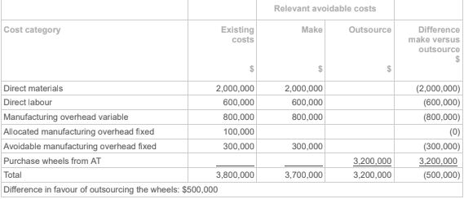  - Refer to the table above for calculation  - The process is to create a table comparing existing costs vs 2 columns (Make & Outsource)  - Then compare each line item and add up to the total costs of make and outsource.  - Choose the option with lowest cost to product the product.  - The difference in favour of outsourcing is the difference between make cost and outsource cost and vice versa.
Riverside Neighbours (RN) is a hotel complex with 210 rooms. It caters to two types of guests – conference attendees and tourists. Conference delegates tend to stay during the week while tourists are more common on Friday and Saturday nights, although some also stay throughout the week. RN has conducted an analysis to determine the effects of different room rates on demand. The two rates are $260 and $210, and the respective number of rooms expected to be booked at each rate for the two types of guests is:  Expected booking numbers for each guest type (per week)  [Type of guest - $260 room rate - $210 room rate]  Conference rooms - 70 / 90  Tourist rooms - 60 / 110  The level of service for the rooms varies depending on the rate charged. A $260 room rate would incur $100 in variable costs and a $210 room rate would incur $95 in variable costs. What rates should RN charge for the different types of guest rooms in order to maximise its profitability?  A. $260 for both conference attendee and tourist rooms.  B. $260 for conference attendee rooms and $210 for tourist rooms.  C. $210 for conference attendee rooms and $260 for tourist rooms.  D. $210 for both conference attendee and tourist rooms. | B | Conference $260 Tourist $260 Conference $210 Tourist $210  Revenue (A) 70 * 260 = $18,200 60 * 260 = $15,600 90 * 210 = $18,900 110 * 210 = $23,100  Var. Costs (B) 70 * 100 = 7000 60 * 100 = 6000 90 * 95 = 8,550 110 * 95 = 10,450  Contribution margin (A – B) $11,200 $9,600 $10,350 $12,650  - Refer to table for calculation of contribution margin by room and price point.  - Look for the 2 highest contribution margins, Highest is for Tourists at $210  [ (110*210) – (110 * 95) = $12,650]  - Second highest is for conference at $260  [ (70 * 260) – (70 * 100) = $11,200]  - Therefore B is the correct answer.
Snug Snoozer (Snug) is an importer of sleeping bags, selling only to retailers who specialise in camping and tramping products. The last two years has delivered no growth in profitability for the company. The chief financial officer (CFO), Ken Strong, is keen to implement an activity­ based costing (ABC) system. Ken believes that a more accurate allocation of overheads between the two products that they sell, will lead to better decision­making and pricing decisions, and thereby provide financial growth for the company. You have been employed on a short­term contract to support Ken on implementing an ABC system. You have identified the following product and cost data:  Product Sleep - 1 Product Sleep 2 - Total$  Imported cost per unit $124 $126  Units sold 8,000 6,920  Overhead costs 400,000  Chief executive officer (CEO) and CFO salaries (part of overhead costs) 240,000  You identify that:  The CEO and CFO do not spend any significant time on one product compared to the other product.  Promotional activities (15% of overhead costs) are based on promoting the company brand.  Based on the above information, and earlier discussions Ken had with the CEO, the following notes had been drafted:  1. The cost in collecting data for two products that have similar costs structures does not justify an ABC system.  2. There is only $100,000 of overhead costs to allocate representing less than 5% of total costs for the company.  3. $400,000 overhead costs can be accurately allocated on an ABC basis.  4. Implementing an ABC system will enable pricing decisions to be adjusted to ensure maximum profitability per product.  Which of the following points provide relevant advice to Snug?  A. Points 3 and 4.  B. Point 3 only.  C. Point 4 only.  D. Points 1 and 2. | D | The cost in collecting data for two products that have similar costs structures does not justify an ABC system – there is nothing in the information that suggests costs or cost drivers are different between the two products.  There is only $100,000 of overhead costs that could be allocated representing less than 5% of total costs for the company – after deducting the CEO and CFO salaries, and the promotional costs, the remaining overhead balance is $100,000. This represents 4.4% of total costs ($2,263,920). An ABC system will accurately allocate the $400,000 overhead costs – $240,000 of the $400,000 relates to salaries that have no cost-driver and cannot be split between the two products; and $60,000 relates to corporate branding that cannot be split between the two products. Therefore, this only leaves a balance of $100,000 that could potentially be allocated between the two products. Implementing an ABC system will enable pricing decisions to be adjusted to ensure maximum profitability per product – pricing decisions are based on a range of factors. It is not the ABC system that enables pricing decisions.
Snug Snoozer (Snug) has done further research on the materials that it has been using in its Super Snug product and developed a higher grade, lighter product for customers who take their adventures seriously. The new product, called the Slim Snug, will replace the Super Snug in approximately eight weeks. Snug currently has 8,000 Super Snugs in stock representing 10 weeks’ worth of stock at existing prices. It is expected that with the launch of the Slim Snug, the remaining stock will need to be written off within a month of the launch. The Super Snug normally sells for $650 and has a gross profit margin of 30% on selling price. The sales team is considering how best to clear stock prior to the release of the Slim Snug and has provided the information below so that you can determine the most appropriate pricing strategy. Ignore any GST implications.  Option - Discount level on selling price - Expected sales period - Expected wastage (units)  1 - 0% - 10 weeks- 1,800  2- 10% - 9 weeks - 1,500  3 - 20% - 8 weeks - 400  4 - 30% - 7 weeks - 0  What is the most appropriate pricing strategy?  A. Option 3.  B. Option 2.  C. Option 4.  D. Option 1. | D | 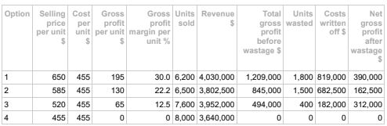  As can be seen from the above table, the most appropriate pricing strategy is option 1 as it provides Snug with the highest net gross profit after wastage.
The following financial analysis shows that Company B should buy a component rather than manufacture the component itself, thereby saving $10,000.  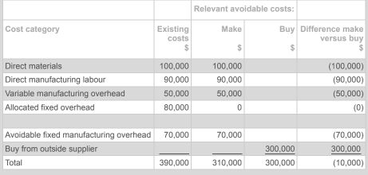  Other issues that need to be considered in the decision include:  I. Additional costs of working capital due to increased inventory holding.  II. Maintaining control over any intellectual property in the design and manufacture of the component.  III. Ability of outside supplier to meet required lead times.  IV. The corporate image of the outside supplier.  V. Additional warehouse required.  What are all the non­financial issues that need to be considered as part of the decision whether to make or buy the component?  A. I, II, III, IV and V.  B. II, III and IV.  C. I and V.  D. I, II, III and V. | B | - For this question we ignore non-financial impacts (see wording, trick question):  - I. Inventory working capital costs –this is a financial issue. Question is asking for non-financial issues only. - Exclude  - II. Control over IP is an important non-financial issue for security / IP protection. – Include  - III. The outside supplier’s ability to meet the required lead times is a non-financial issue. Failure to meet lead times will disrupt continuity of supply. Include  - IV. Customer perception of buying from an overseas supplier is a non-financial issue. Include  - Additional warehouse is a financial issue as it will cost more. Exclude
Phone 4 U (P4U) is a new mobile phone manufacturer to the market. P4U has three new models planned, with a number of components sourced overseas.  Product details for each model are as follows:  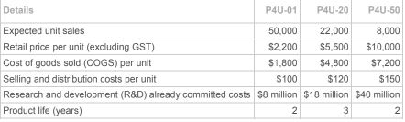  Which product has the lowest gross profit margin % per unit and which product has the highest mark­up % per unit? Note that the mark­up % is based on COGS.  A. P4U-20 has the lowest gross profit margin % per unit and P4U-50 has the highest mark-up % per unit.  B. P4U-01 has the lowest gross profit margin % per unit and P4U-01 has the highest mark-up % per unit.  C. P4U-50 has the lowest gross profit margin % per unit and P4U-20 has the highest mark-up % per unit.  D. P4U-20 has the lowest gross profit margin % per unit and P4U-01 has the highest mark-up % per unit. | A | 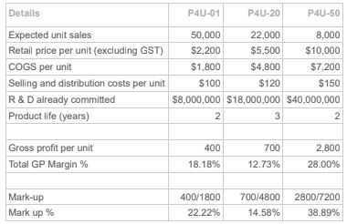  As shown by the calculations in the above table, P4U-20 has the lowest gross profit margin % per unit and P4U- 50 has the highest mark-up % per unit. Note that the mark-up % is based on COGS.
You are a CA working as a business analyst for an accounting software company. As part of your remuneration package you have a company car. Under company policy you have unlimited use of the car, as long as you are the driver. While on your recent holiday, your partner drove the car to the supermarket and backed into a car park pillar, putting a dent into the rear of the car. Your partner advises you to tell your boss when you return to work on Monday, that it was you who drove the car. Doing so would ensure the company insurance would cover the repair cost of the car. What is the key fundamental ethical principle at risk in this situation?  A. Professional behaviour.  B. Objectivity.  C. Confidentiality.  D. Integrity. | D | If someone else drives your company car, then you are not complying with the requirements of company policy regarding the use of the car. The principle of integrity then becomes an issue if you fail to tell your boss who was driving the car at the time of the accident. Therefore, integrity is the key fundamental ethical principle at risk (para. 100.5(a) and s. 110 IESBA Code of  Ethics for Professional Accountants).
UGF is a food-processing operation, turning fresh vegetables into canned vegetables. UGF sells only to supermarkets. The detail on the labels for each product are important as consumers are growing in their awareness of food quality. The chief financial officer, Meja Cullen, wishes to gain a clear understanding of the cost of quality to the organisation. The following items are examples of cost of quality issues:  1. Supplier audits to ensure supplier processes and products meet the UGF quality criteria.  2. Rework of product due to incorrect labelling as identified by the production supervisor.  3. Return of fresh vegetables to suppliers due to poor quality.  4. Products returned from the supermarkets due to incorrectly labelled product.  Which item(s) would be classified as internal failure costs as part of the cost of quality?  A. Items 2, 3 and 4.  B. Item 1 only.  C. Item 4 only.  D. Item 2 only. | D | Rework of product due to incorrect labelling as identified by the production supervisor – this cost of rework is identified before the product is delivered to the customer, therefore it is internal failure costs and not external failure costs.
Rhoda Bikes (RB) manufactures mountain bikes (all are two wheeled bikes) for professional and casual riders alike. Located in  Melbourne, the factory sells to both local and overseas buyers.  Currently RB makes all the parts used in the manufacture of the bikes. Recently the company received a proposal from AT Wheels  Company, which is able to supply the bike wheels at $40 per wheel. Demand is expected to be 40,000 bikes this year. The expected annual cost to manufacture the wheels for these bikes are as follows:  Direct materials 2,000,000  Direct manufacturing labour 600,000  Manufacturing overhead variable 800,000  Manufacturing overhead fixed 400,000  Total 3,800,000  In respect of the manufacturing overhead fixed, if the production of wheels is discontinued:  1. The allocation of $100,000 of administrative overhead will not change.  2. The remaining $300,000 is manufacturing overhead fixed that specifically relates to the production of wheels and will no longer  be incurred. Should RB outsource the production of wheels?  A. Yes, as the difference in favour of outsourcing is $500,000.  B. Yes, as the difference in favour of outsourcing is $2,100,000.  C. Yes, as the difference in favour of outsourcing is $600,000.  D. Yes, as the difference in favour of outsourcing is $2,200,000. | A
Hillside Wonder (HW) is a hotel complex with 210 rooms. It caters to two types of guests – conference delegates attending conferences at the conference centre next door, and tourists visiting the area. Conference delegates tend to stay during the  week while tourists are more common on Friday and Saturday nights, although some also stay throughout the week. HW has conducted an analysis to determine the effects of different room rates on demand. The two rates are $260 and $210, and the respective number of rooms expected to be booked at each rate for the two types of guests is as below:  Expected booking numbers for each guest type (per week)  Type of guest - $260 room rate - $210 room rate  Conference attendee rooms booked - 60 - 90  Tourist rooms booked - 50 - 105  The level of service for the rooms varies depending on the rate charged. A $260 room rate would incur $110 in variable costs  and a $210 room rate would incur $95 in variable costs.  For the purposes of this question, ignore GST.  What rates should HW charge for the different types of guest rooms in order to maximise its profitability?  A. $260 for conference rooms and $210 for tourist rooms.  B. $210 for both conference attendee and tourist rooms.  C. $210 for conference rooms and $260 for tourist rooms.  D. $260 for both conference attendee and tourist rooms. | B | 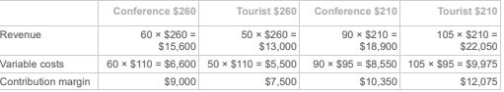  As the contribution margin is greatest for conference rooms at $210 per night and tourist rooms at $210 per night, these are the rates that should be used.
The following financial analysis shows that Company A should buy a component from an overseas supplier rather than manufacture the component itself, thereby saving $10,000. The overseas supplier will arrange free delivery to Company A’s  central warehouse.  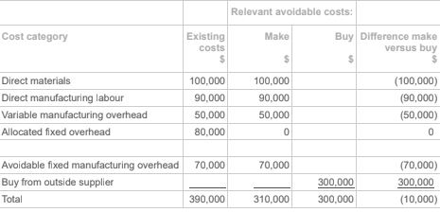  Other issues that may need to be considered in the decision include:  I. Freight costs from the central warehouse to the customer.  II. Customer perception of buying from an overseas supplier rather than manufacturing locally.  III. Ability of outside supplier to meet required lead times.  IV. Additional staff member required in the country of the outside supplier to be utilised as the key contact person.  V. The reliability and reputation of the outside supplier.  What are all the relevant financial issues that need to be considered as part of the decision whether to make or buy the  component?  A.IV only.  B.II, III, and V.  C.III and IV.  D.I only. | A | I. Freight costs from the central warehouse to the customer – although this is a financial issue, it is not relevant to the decision as it applies to both options.  II. Customer perception of buying from an overseas supplier is a non-financial issue.  III. Ability of outside supplier to meet required lead times. The outside supplier’s ability to meet the required lead times is a non-financial issue. Failure to meet lead times will disrupt continuity of supply.  IV. Additional staff member required overseas will result in additional salary/ wages expense therefore this is a relevant financial issue.  V. The reliability and reputation of the outside supplier. Reliability and reputation are non-financial issues.
Phone 4 U (P4U) is a new mobile phone manufacturer to the market. P4U has three new models planned, with a number of  components sourced overseas.  Product details for each model are as follows:  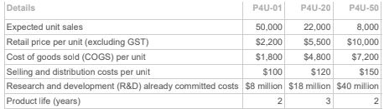  Which product has the lowest gross profit margin % per unit and which product has the highest mark-up % per unit? Note that  the mark-up % is based on COGS.  A. P4U-20 has the lowest gross profit margin % per unit and P4U-01 has the highest mark-up % per unit.  B. P4U-50 has the lowest gross profit margin % per unit and P4U-20 has the highest mark-up % per unit.  C. P4U-01 has the lowest gross profit margin % per unit and P4U-01 has the highest mark-up % per unit.  D.P4U-20 has the lowest gross profit margin % per unit and P4U-50 has the highest mark-up % per unit. | D | As shown by the calculations in the above table, P4U-20 has the lowest gross profit margin % per unit and P4U- 50 has the highest mark-up % per unit. Note that the mark-up % is based on COGS.
Sunshine Cereal Bars Limited produces 20 different product lines. An Activity based costing (ABC) is to be trialled on three different products.  The three products to be piloted are:  Product 1: Raisin Cereal Bar  Product 2: Hazelnut Cereal Bar  Product 3: Oats & Honey Cereal Bar  The costing information he has established is outlined in the following tables:  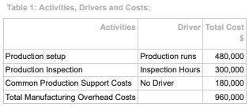  The activity driver analysis for the ABC system revealed the following activity usage relevant to the three products as per Table 2.  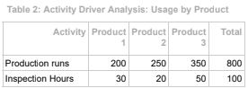  The current financial data revealed the following information of these three products.  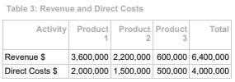  The current costing system (traditional system) allocated all the manufacturing overhead costs based on the proportion of  direct costs per product.  What is the difference in profitability for Product 1 between an ABC system and the current traditional costing system (rounded to nearest $000)?  A.$180,000.  B.$270,000.  C.$210,000.  D.$240,000. | B | 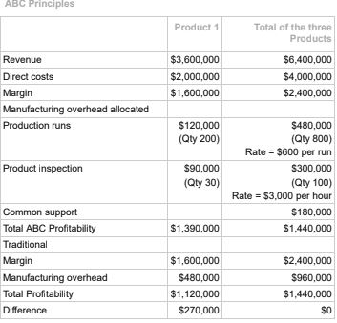
EBA is a chartered accounting firm of 20 partners and 200 staff located in Melbourne, Victoria. It provides a range of services to clients including taxation, financial reporting and advisory. In setting fees for its services, EBA considers the rates charged by other second tier firms in Melbourne, and then sets its fees mid–range. Within the accounting industry, EBA is known to earn above average margins on its business. EBA has achieved this by employing the latest technology to reduce its transaction costs and outsourcing some client processing to companies in Sri Lanka. What is the generic strategy that EBA employs?  A. Broad differentiation.  B. Broad cost leadership.  C. Focused differentiation.  D. Focused cost leadership | D | EBA is only located in Melbourne. While EBA would be considered a relatively larger firm within  its segment of the market, it has chosen to only target Melbourne, Victoria, within the Australian  market. This fact represents a focus strategy (a geographic focus within the Australian market).  EBA is employing a low cost strategy, as it employs the latest technology to reduce its  transaction costs. The firm’s pricing is market–based, resulting in EBA using the lower  transaction costs to improve its margin, rather than to provide lower prices to customers.  Therefore, the generic strategy that EBA employs is focused cost leadership.
You work as a manager for EBA chartered accountants. A new client has asked you to help them prepare their year end financial statements for a family owned scrap metal recycler. Historically, the client uses these financial statements for private purposes (reporting to the family) and as the basis for completing their annual income tax return. In preparing the financial statements, you note that revenue has increased by 75% on the prior year; however, the value of inventory in the balance sheet is the same as that in the prior two years. When queried about this anomaly, the client informed you that they did not undertake a stock take and they know the value in the balance sheet was not accurate. However, they were not concerned as the business continues to grow and there are no excess stock issues. Your client is not expecting an adjustment for this issue. What is the key fundamental ethical principle at risk to you in this situation?  A.Integrity.  B. Professional competence and due care.  C. Objectivity.  D. Confidentiality. | A | The client is expecting EBA to prepare financial statements that are not accurate, and to process  false or misleading statements. Therefore, integrity is the key fundamental ethical principle at risk (para. 100.5(a) and s. 110 IESBA Code of Ethics for Professional Accountants).
TwoTones is a manufacturer of widgets. The table below provides the financial details of the customer supply cost per widget:  Direct materials $100  Manufacturing labour $80  Variable manufacturing overhead $65  Allocated fixed manufacturing overhead $75  Variable selling and administration costs $5  Variable distribution costs $15  Total customer supply cost per widget $340  TwoTones currently has the opportunity to source widgets from ThreeTunes at a cost of $265 each. It is not expected that fixed costs will be impacted by this opportunity. The mgmt acctnt sees this as an excellent option, as it represents a savings on the manufacturing costs of $55 per widget. Qualitative issues were considered and the results are shown below:  Possible Problem Solution  Quality of product from Threetunes Contractual agreement to maintain quality with penalties for breaches  Reliability of production and delivery ThreeTunes has to provide a guarantee of reliable services.  Which statement is correct in relation to the mgmt acctnt’s make or buy decision process?  A. The mgmt acctnt is incorrect, as they have not included the other variable costs associated with selling, administration and distribution.  B. The mgmt acctnt is correct, as it is financially sound and there are no qualitative offsetting factors to detract from the arrangement.  C. The mgmt acctnt is incorrect, as while there is a cost benefit with the option, there are other qualitative factors that have not been considered.  D. The mgmt acctnt is incorrect, as the savings figure calculated is incorrect and actually results in a loss of $20 per unit. | D | 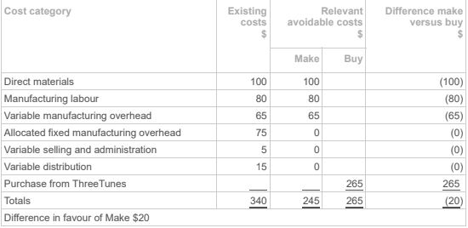  The calculation of the make cost should not include the allocated fixed manufacturing overhead of $75, as this cost will still need to be recovered whatever decision is made. Therefore, the comparison cost is $245 to make versus $265 to buy. The qualitative issues do not provide a reason not to proceed with making the widgets, and the variable distribution, selling and administration costs will still be costs, even if TwoTones buys the product.
Based in Sydney, EQP is a manufacturer of high-quality marine engines. As part of its quality control program, the following activities occur:  1. Engineers perform regular maintenance on all machinery in line with the machinery requirements specified by the supplier.  2. Staff complete a thorough audit, including a site visit, of all new suppliers of marine components it uses in its manufacturing processes.  3. Production supervisors record all unplanned downtime of machinery.  4. Staff test all marine engines before making them available for sale. Any engines that fail the test are placed in a thorough review process that includes requiring sign-off from two production supervisors.  Which cost of quality activities are classified as prevention costs?  A. 1 and 2.  B. 4 only.  C. 3 and 4.  D. 1 only. | A | Engineers performs regular maintenance on all machinery in line with the machinery requirements specified by the supplier – this is classified as prevention costs. Staff complete a thorough audit, including a site visit, of all new suppliers of marine components it uses in its manufacturing processes – this is classified as prevention costs. Production supervisors record all unplanned downtime of machinery – unplanned downtime costs are classified as internal failure costs. Staff test all marine engines before being available for sale. Any engines that fail the test are placed in a thorough review process that includes requiring sign–off from two production supervisors – testing the marines engines are classified as appraisal costs, while any that fail the test are classified as internal failure costs.
Cool Junk is a manufacturer of small, low cost items for teenagers. It has been considering implementing activity based costing (ABC) within its business, with a view to improving the accuracy of its costing systems around both inventory and customers. Anne is the mgmt acctnt and she has been asked to determine whether Cool Junk should implement ABC. Anne has been able to determine the following average cost profile for goods sold by Cool Junk:  Component - Percentage (%)  Direct materials 45  Direct labour 40  Variable overheads 10  Fixed overheads 5  Total 100  To keep the costs down, all customer orders are placed online, and customers are responsible for all delivery costs. Based on the above information, which of the following statements is correct?  A.Cool Junk should only implement ABC for customers, as there would be limited benefit in applying ABC to inventory costs.  B.Cool Junk should only implement ABC for inventory, as there would be limited benefit in applying ABC to customer costs.  C.Cool Junk should not implement ABC as the benefits are likely to be small and would not outweigh the costs.  D.Cool Junk would obtain significant advantage by implementing ABC for both inventory and customers. | C | ABC focuses on the allocation of overheads. Based on the information provided, overheads  associated with Cool Junk’s inventory are small (15%), of which only 5% are fixed. This would  suggest that overhead costs are a small component of the overall inventory costs, and therefore there is likely to be of little benefit in applying ABC to inventory.  Customers are required to place orders online and pay their own delivery costs. Again, this  suggests that overhead costs associated with servicing customers are low, and therefore the  potential benefits in implementing ABC at the customer level would also be minimal.
Argy Bargy is a retailer with three product lines, with all products being provided by a single supplier. Under its traditional costing method, the store support (i.e. ordering and delivery costs) is allocated based on warehouse staff man hours. Below is Argy Bargy’s current analysis of the gross profit of each product line:  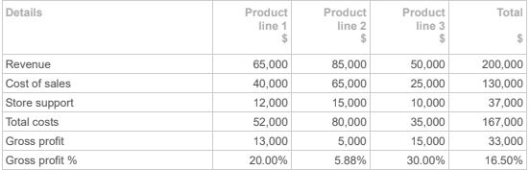  Argy Bargy wants to improve its overall gross profit percentage and has therefore decided that it should drop Product line 2 as it has the lowest gross profit. Argy Bargy has asked its company accountant to complete a gross profit analysis based on activity based costing (ABC). The accountant has obtained the following information on store support costs.  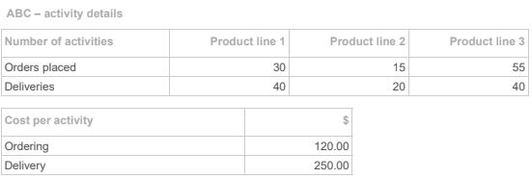  What would be the gross profit percentage for Product line 2 under ABC?  A. 4.00%.  B. 7.53%.  C. 15.53%.  D. 16.29%. | C | Existing gross profit 5,000  Add back: Current support costs 1 5,000  Less: Revised ABC support costs 6,800  Revised ABC gross profit 13,200  Gross profit percentage:  Gross profit divided by revenue: $13,200 ÷ $85,000 = 15.53%.  Store support costs:  ($120 × 15) + ($250 × 20) = $6,800.  This question relates to Unit 3, Learning outcome 1.
Toby Tonks (TT) designs, manufactures and markets 3D printers. TT has a new model planned (Model T), with a number of components sourced overseas. Details for the model are as follows:  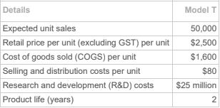  TT has set its target price based on market conditions. What is the expected mark up % per unit for Model T?  A. 36%.  B. 56.25%.  C. 35.63%.  D. 51.25%. | B | 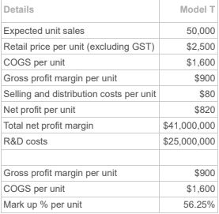
Bruno Limited (Bruno) is a manufacturing company that produces multiple products with differing production processes. Bruno requires new products to be launched regularly, with the ubsequent write-off (wastage) from the replaced product a common occurrence. You have been provided the following information for Product Gen Z (ignore any GST implications). Product Gen Z will be replaced soon with a new product.  Current selling price $200 per unit  Gross Profit margin % 30% on the selling price  Expected wastage (units) when 10% discount is applied to the selling price 100  What is the Gross Profit Margin % per unit and the expected wastage costs (write–off) for Product Gen Z, when a 10% discount is applied to the selling price?  A. Gross Profit margin per unit % = 29%, and expected wastage = $18,000  B. Gross Profit margin per unit % = 22%, and expected wastage = $18,000  C. Gross Profit margin per unit % = 29%, and expected wastage = $14,000  D. Gross Profit margin per unit % = 22%, and expected wastage = $14,000 | D | Current selling price = $200 per unit.  10% discount selling price = $180 per unit  Cost per unit = $200 × 0.70 = $140 per unit  Gross Profit per unit = $180 – $140 = $40 per unit  Gross Profit Margin per unit % = $40 ÷ $180 = 22%  Expected wastage = 100 × $140 = $14,000
Tiger Tassy (TT) is a bike manufacturer and retailer based in Tasmania. Local cost pressures has forced TT to investigate overseas supplier options for some of the key bike components.  The following list was provided to you to support your decision making on this issue:  1. The foreign exchange rate fluctuations  2. Shipping costs from the overseas supplier  3. Overseas supplier environmental reputation  4. Quality of components from overseas supplier  What are the relevant financial issues that need to be considered as part of the decision whether to continue to make the components or buy from the overseas supplier?  A. 3 and 4.  B. 2 and 3.  C. 1 and 2.  D. 2 only. | C | 1. The foreign exchange rate fluctuations – this is a financial consideration as the fluctuations directly impacts on costs.  2. Shipping costs from the overseas supplier – this is a financial consideration as this impacts on the costs of buying the components from overseas.  3. Overseas supplier environmental reputation – this is a qualitative consideration rather than a financial consideration.  4. Quality of components from overseas supplier – this is a qualitative consideration rather than a financial consideration.
High Flyers airline operates flights between Sydney and Adelaide. The revenues and costs associated with each flight are:  Ticket price per seat $650  Flight crew costs per flight $35,000  Food and beverage costs per passenger $50  Other flight related costs per passenger $15  Fuel costs per flight $65,000  Airport costs per flight $15,000  Maximum passengers per flight 350  Flights are currently operating at only 50% capacity. Management wants to increase the yield achieved per flight, and the marketing department is suggesting that the airline offers late booking, non-refundable discounted tickets. They believe that by offering a 40% discount for late bookings, they can sell the remaining seats on each flight. High Flyers has asked its mgmt acctnt to undertake an analysis of this suggestion for increasing the yield per flight. For the purposes of this question, ignore GST.  What increase in per flight profit can be achieved by the suggestion from the marketing department?  A. $59,500.  B. $39,375.  C. $34,125.  D. $56,875. | D | A 40% discount would make the selling price per seat for the remaining seats $390 ($650 × 60%). Deducting the cost per passenger of $65 (food and other) leaves a contribution margin per passenger of $325 and this multiplied by the 50% extra passengers is $325 × 175 = $56,875.

